Conversational AI — Phase 2 (Conversation Design)
Designing human-centred, resilient conversation flows on paper — before anything is built in Cognigy.
Role: Conversation Architect (the BA hat comes off here)
Version 1.1 · Last updated 3 August 2026 · Owner: Denis Šuško · Status: Living document (review each quarter)
How to reuse this template
This is a reusable framework. The running example — an online-retailer “OrderBot” automating check_order_status and cancel_order — is illustrative only. On a real project, swap these levers for the client’s specifics:
- Client, brand voice & persona
- In-scope intents
- Business-rule thresholds (here: cancellation blocked when order value > €500)
- Agent desktop / CRM for handover (here: Salesforce Service Cloud)
- Authentication method (here: logged-in webchat session + email check)
- Channels in scope (here: webchat only)
In the companion workbook, grey cells are illustrative examples and blue cells are yours to fill in.
What this phase is. In Phase 1 you decided which conversations are worth automating and proved the business case. In Phase 2 you design exactly how those conversations go — turn by turn — as scripts, a flowchart, a data dictionary and a handoff spec. Everything is settled on paper so the build team codes a design that is already agreed, not one they improvise.
The risk it prevents: a bot that sounds robotic, loops endlessly, freezes on unexpected input, or frustrates customers into calling anyway.

1. Phase 2 at a Glance
Aspect | Detail
Objective | Turn abstract intent requirements into visual flows, dialogue scripts, error-handling logic and data schemas.
Your role | Lead design-review workshops, write dialogue scripts, model conversation branching, define variable payloads.
Primary tools | Scripting: Word / Google Docs · Diagramming: Lucidchart / Bizagi · Data mapping: Excel / Google Sheets.
Key risk prevented | A bot that sounds robotic, loops endlessly, gets stuck on invalid input, or frustrates customers.

2. Prerequisites
Do not start Phase 2 until both of these are in hand:
✓ Signed-off Phase 1 charter — executive approval on in-scope intents (check_order_status, cancel_order) and the out-of-scope boundaries.
✓ API field-mapping confirmation — written confirmation from IT on the data fields available (e.g. the backend returns order_status, order_total, and a can_cancel boolean). Design against confirmed fields, never assumed ones.

3. Required Customer Inputs
Gather these from stakeholders at kickoff:
- Brand voice & persona guidelines — tone (professional vs. friendly), emoji use, maximum message length, standard greetings.
- Real call/chat logs — how customers actually phrase requests, and how agents respond. Your scripts should echo real language, not invented phrasing.
- Escalation policies — rules for human transfer: business hours, queue-routing tags, and how angry customers are handled.

4. Deliverables — the Phase 2 Output Package
Four artifacts handed to the customer and the technical build team:
- Dialogue Script Specification — verbatim scripts for ideal conversations, edge cases and repair loops.
- Visual Dialogue Flowchart — the full decision tree: turn-taking, slot filling, API decision nodes and error states.
- Variable & Entity Dictionary — the schema of extracted entities, input variables and session flags. (Provided as an Excel template.)
- Handoff & Agent-Context Spec — the JSON payload sent to the agent desktop (e.g. Salesforce Service Cloud) on escalation.

5. Six Design Principles (read before you write a word)
These are the habits that separate a resilient assistant from one that dead-ends. Everything in the action plan below applies them.
- One turn, one job. Ask for one thing at a time. Keep each message to 2–3 sentences, scannable on a phone.
- Confirm before anything irreversible. Cancelling an order can't be undone — always get an explicit yes first.
- Repair, don't dead-end. Distinguish no-match (the bot didn't understand) from no-input (the user said nothing). Each gets a different, helpful reprompt — never a blunt "I didn't get that" on loop.
- Always leave an exit. Universal commands work at any turn: "agent" escalates, plus "help", "start over", "cancel". A user must never feel trapped.
- Set expectations on waits. Before an API call, say "One moment while I check…" so a 2-second pause doesn't read as a freeze.
- Protect personal data. Verify identity before revealing order details, and don't echo full personal data back unnecessarily (GDPR). Confirm against something the customer already knows.

6. Step-by-Step Action Plan

Step 1 — Establish the bot persona & formatting rules (30 min · Word)
Agree 3–5 non-negotiable rules for how the assistant communicates. Example set:
- Brevity: maximum 2–3 sentences per turn.
- Tone: empathetic, clear, direct. No slang.
- Format: bullet points for choices; keep text scannable on mobile webchat.

Step 2 — Write verbatim sample scripts (60 min · Word)
Write word-for-word transcripts for the main paths. Start with these five; the first three are your core, the last two are the ones juniors skip.
Script 1 — Happy path (cancel_order)
Bot: Hi! I'm the Virtual Assistant. How can I help you today?
User: I need to cancel my order.
Bot: I can help with that. What is your 4-digit Order ID?
User: 1001
Bot: Thanks. And what email address is on the order?
User: alex@test.com
Bot: One moment while I check… (sets expectation for the API call)
Bot: I found order #1001 — it hasn't shipped yet. Just to confirm: you'd like to cancel it? (yes / no) (explicit confirm before irreversible action)
User: Yes
Bot: Done — order #1001 is cancelled, and a confirmation email is on its way to alex@test.com. Anything else I can help with?
Script 2 — Business-rule exception (already shipped)
Bot: One moment while I check…
Bot: I found order #1002, but it has already shipped, so I can't cancel it automatically. Once it arrives you can return it free here: [return-portal link]. Would you like to speak with an agent?
Script 3 — Repair loop (2-strike strategy: no-match)
Bot: What is your 4-digit Order ID?
User: I don't know my order number
Bot: No problem — your 4-digit Order ID is in the subject line of your confirmation email. Please type those 4 digits. (Strike 1: subtle, helpful reprompt)
User: my package is late
Bot: I'm still not getting an Order ID. Would you like to: 1) try the Order ID once more, or 2) speak to a live agent? (Strike 2: explicit choice, then escalate)
Script 4 — No-input (user goes silent)
Bot: What is your 4-digit Order ID?
User: … (no reply)
Bot: Still there? Whenever you're ready, just type your 4-digit Order ID. (different from a no-match: assume distraction, not confusion)
Script 5 — API error / timeout
Bot: One moment while I check…
Bot: Sorry — I can't reach our order system right now. I can try again, or connect you to an agent who can look this up. Which would you prefer?

Step 3 — Create the Variable & Entity Dictionary (30 min · Excel)
Document every parameter the bot extracts or holds in memory — name, type, source, example and validation rule. Use the companion workbook (ConvAI Ph2 Conversation Design Templates.xlsx), which is pre-filled with the cancel_order example. A sample of what it captures:
Parameter | Type | Source | Example | Rule
input_order_id | Entity / Slot | NLU (@sys.number) | 1001 | 4-digit regex
input_email | Entity / Slot | NLU (@sys.email) | alex@test.com | valid email
order_status | Variable | API response | Processing | Processing/Shipped/…
order_total | Variable | API response | 150.00 | number, EUR (> €500 escalates)
fallback_count | System var | Session memory | 1 | integer, max 2

Step 4 — Draw the visual flowchart (90 min · Lucidchart / Bizagi)
Map the whole logic visually. The diagram below is the cancel_order flow. One correction on the original sketch: the outcomes after the API call aren't parallel — they're a hierarchy. Check status first (a shipped order can't be cancelled at any price); only if it's cancellable do you check the €500 value threshold; only then do you confirm and execute. Designing them as parallel branches lets contradictory paths fire at once.
The full-resolution image (flow.png) and an editable version (flow.mmd, importable into Lucidchart via File ▸ Import ▸ Mermaid) are in the project folder.

cancel_order — conversation flow
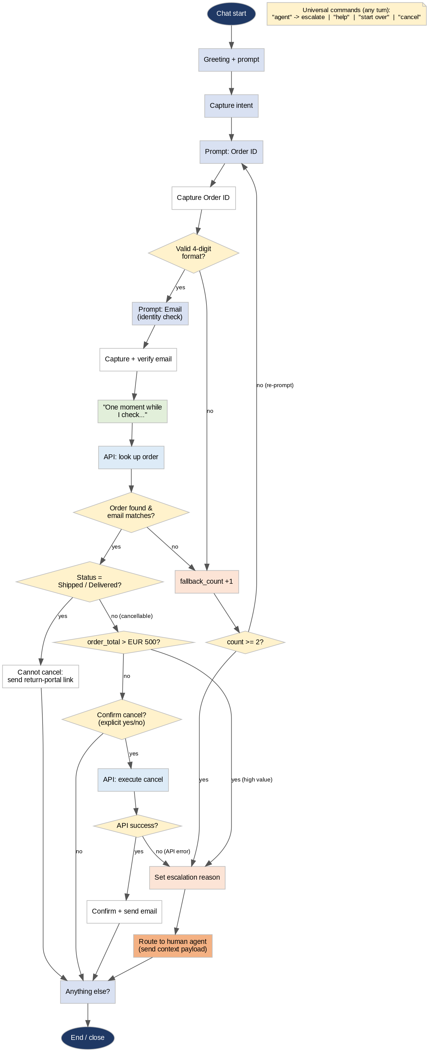

Step 5 — Define the human-escalation payload (30 min · JSON in Docs)
On handoff, the bot sends a structured context summary to the agent desktop so the customer never repeats themselves. (Field-by-field spec is in the Excel workbook.)
{
"handoff_trigger": "High_Value_Order_Cancellation",
"customer_data": {
"order_id": "1003",
"email": "taylor@test.com",
"order_total": 750.00,
"order_status": "Processing"
},
"bot_session_summary": {
"detected_intent": "cancel_order",
"confidence_score": 0.96,
"fallback_count": 0,
"reason_for_transfer": "Order value exceeds automated limit (EUR 500)."
}
}

Step 6 — Design review & client sign-off (60 min · workshop)
Run a walkthrough with customer stakeholders:
- Read the happy-path and repair scripts line by line.
- Walk the flowchart to confirm every branch matches their real policies.
- Get official sign-off on the design package before any build begins.

7. Definition of Done
Design is finished when every path below has a written script — not just the happy one. This checklist is in the companion workbook (Script Coverage Checklist tab); tick each before sign-off:
✓ Happy path completes end to end
✓ Shipped order → return-portal link
✓ High-value (> €500) → route to human
✓ Explicit confirmation before the cancel action
✓ No-match and no-input each handled distinctly
✓ 2-strike fallback escalates instead of looping
✓ Identity-check failure handled
✓ API error / timeout handled
✓ "Agent" / "help" / "start over" work at any turn

8. Version History
Living document — log every material change so reviewers see what moved.
Version | Date | Author | Summary of changes
1.0 | 3 Aug 2026 | Denis Šuško | Structured the Phase 2 framework; added design-principles section, no-input & API-error scripts, universal commands, latency and PII/GDPR guidance, and corrected the post-API decision hierarchy (status → value → confirm).
1.1 | 3 Aug 2026 | Denis Šuško | Added “How to reuse this template” callout and labelled the running example as illustrative.

